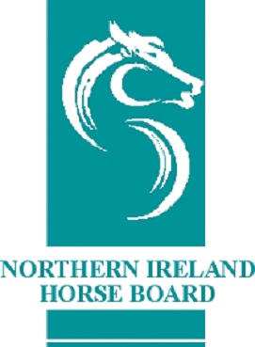
NORTHERN IRELAND HORSE BOARD
CREDIT/ DEBIT CARD PAYMENT FORM
WE ACCEPT THE FOLLOWING CARD TYPES: VISA CREDIT & DEBIT, MASTERCARD CREDIT & DEBIT AND AMERICAN EXPRESS
THIS INFORMATION WILL BE DESTROYED ONCE THE TRANSACTION HAS BEEN PROCESSED
Cardholder’s Name

Cardholder’s Address

£

Card Type:
Mastercard Credit Debit

Visa Credit Debit

American Express

Card Number: Expiry Date:

Card Security Number Postcode Amount:
(3 Digits on the reverse of card) (of cardholder address)

I authorise the Northern Ireland Horse Board to charge my card details above.
Signed: Print Name

Date:

/

